The maximum transmission unit, here on referred to as MTU, is the maximum amount of bytes that can be encapsulated in an IP packet. The MTU size includes the data payload, any transport headers (such as TCP, UDP, GRE, RTP, or ICMP), and the IP header:

**SET/Replace MTU with 1476 for GRE and IPSec Tunnel (1500-24) [SAIPA] or 1478 for ADSL or PPPoA**

**Calculation mechanism:**

**https://www.sonicwall.com/en-us/support/knowledge-base/170505851231244**

**How To: Change and Check Windows MTU Size**

[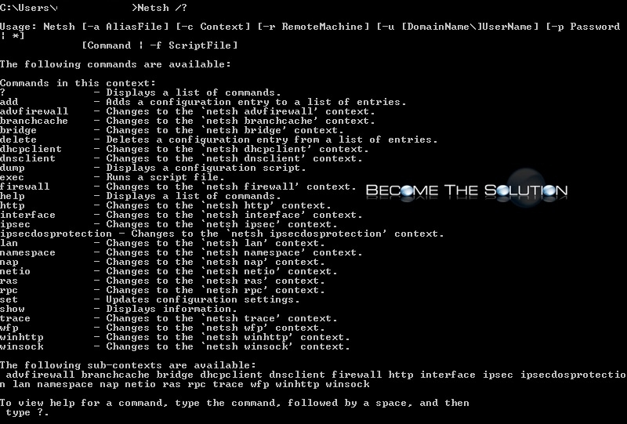](https://becomethesolution.com/images/easyblog_articles/846/netsh-all-commands-windows.jpg)

As part of network troubleshooting, you may need to check or change the **Maximum Transmission Unit (MTU)** on your Windows machine network interface card. The MTU is the size of a network packet that can be communicated in a single network transmission. Learn more about testing [**here.**](https://becomethesolution.com/blogs/path-mtu-determine-mismatching-maximum-transmission-unit-across-links)

**First, let’s check MTU settings in Windows.**

1. Open a Command Prompt CMD (Right Click CMD -> Run Ad Administrator)

2. Type the following:

netsh interface ipv4 show subinterfaces

3. Our MTU size is **1500** which is the default MTU size on most systems.

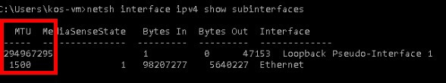

**Change Windows MTU Size**

1. Open a Command Prompt CMD (Right Click CMD -> Run Ad Administrator)

2. Type the following commands in order

netsh

interface

ipv4

3. Your command window will now be at the prompt to change MTU using the next command below.

4. Finally, type the following command to change your Windows MTU. In the example, we will be changing the MTU to 1200.

**Note:** the “Local Area Connection 3” will be name of the interface you see when you ran *netsh interface ipv4 show* subinterfaces command. This will likely be a different name.

set subinterface “Local Area Connection 3” mtu=1200 store=persistent

Windows netsh set subinterface mtu

**\* Please use the comment form below to let us know if you experience issues, have questions, or can provide solution. We want and encourage feedback. \***

# Changing the MTU size in Windows Vista, 7 or 8

Sometimes a computer may struggle to reliably receive and transmit data – resulting in slow speeds or interrupted access to some sites and Internet services. Altering the MTU size can help resolve these problems. This guide shows you how.

## Open a Command Prompt in Administrator Mode:

1. Click the **Windows button** on the task bar.
2. Click **All Programs**.
3. Click **Accessories**.
4. Right-click on **Command Prompt** and click **Run as administrator**.
5. If prompted click the **Allow** button.

## Setting the MTU Size:

Once the Command Prompt window is open follow the steps below to change the MTU size:

1. Type **netsh interface ipv4 show subinterface**
2. Press Enter.
3. You will see a list of network interfaces.
4. Type **netsh interface ipv4 set subinterface “Local Area Connection” mtu=1458 store=persistent**  
   You should replace Local Area Connection with the name that appeared in the “Interface” column from steps 1-3.
5. Press Enter.
6. Restart you computer and then test again.

If you still have problems after modifying the MTU repeat the above steps - replacing the numbers **1458** with **1430** – restart the computer and test again. If you still have problems refer to our [Troubleshooting guides](http://zen.co.uk/support/broadband.aspx#ts) for further assistance.

## Help us improve our Knowledge Base:

Was this article helpful? Could it be improved? Please help us improve our Knowledge Base by rating it and providing your feedback in the section below.

Posted 29th January 2014  
<https://support.zen.co.uk/kb/Knowledgebase/Changing-the-MTU-size-in-Windows-Vista-7-or-8>